11.30 EVALUATION OF SYSTEM OF INTERNAL CONTROL
The following describes the functionality and features included in Probe Audit Premium+

Objective

The objective of this document is to obtain an understanding of the components of the entity’s system of internal control relevant to the preparation of the financial statements, and to evaluate the design and implementation of controls within the control environment, the entity’s risk assessment process, and the entity’s process to monitor the system of internal control.

The following key concepts of the Probe Audit Premium+ Methodology are set in this document:
- Control risk at financial statement level
- Understanding of the entity’s control environment, risk assessment process, and monitoring activities (ISA 315)
- Control risk assessment that determines the nature, timing, and extent of further audit procedures

Document placement
Document 11.30 – Evaluation of system of internal control can be found in the Planning and risk assessment procedures folder in the Caseware document manager.
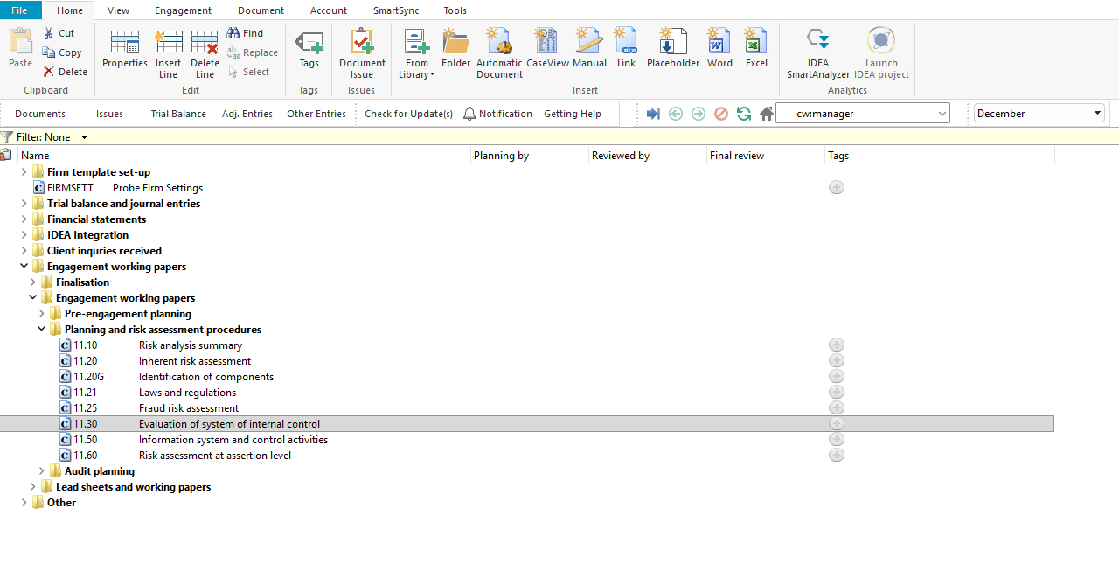

Document content
This document is designed to be a questionnaire type document with space for a comment or further description.
This document evaluates three of the five components of the entity’s system of internal control as required by ISA 315 (Revised 2019):
- Control environment – evaluates the integrity and ethical values of the entity, oversight responsibilities, organisational structure, commitment to competence, and accountability.
- Risk assessment process – evaluates how management identifies business risks, assesses their significance, and decides upon actions to manage those risks.
- Monitoring – evaluates how the entity monitors the effectiveness of the system of internal control, including IT controls and remediation of deficiencies.
This document is divided into different bookmarks in the document map to assist you with the evaluation of internal control:
- Risk assessment procedures
- Control environment
- Risk assessment process
- Monitoring
- Conclusion
- Risk of material misstatement
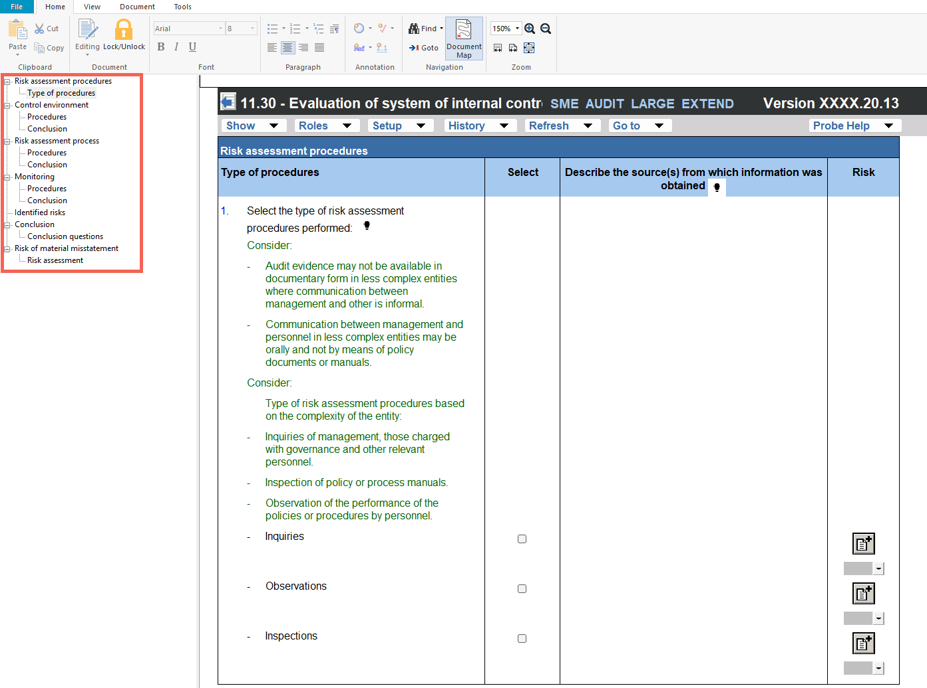
Each component section includes a separate conclusion where the engagement team evaluates whether the component is appropriate, considering the nature and complexity of the entity. Conclusion questions for the control environment and monitoring sections also address whether control deficiencies were identified that may undermine the other components of the system of internal control.

Layout
Column | Input required | Outcome
Risk assessment procedures
Type of procedures | No input is required in this column. | No impact on the engagement file.
Select | Select the risk assessment procedures performed by clicking on the relevant tick box (i.e. inquiries, observations and/or inspections). | No impact on the engagement file.
Describe the source(s) from which information was obtained | Insert a short description of the sources of information from which the understanding was obtained or the procedures performed. When inquiries is selected, record the name and designation of the interviewee and the date of the inquiry. | No impact on the engagement file.
Risk | Raise a risk or event, if necessary, relating to the question or the responses reflected. | A risk or event will be recorded in the relevant document. The engagement file will then prompt the engagement team for appropriate responses to the risk or event recorded.
Control environment / Risk assessment process / Monitoring
Procedures | No input is required in this column. | No impact on the engagement file.
Description of processes | Include a description of the entity’s processes relevant to the question. Describe how the entity has designed and implemented the control or process being evaluated. | No impact on the engagement file.
Explain how you verified your understanding of the processes | Describe the procedures performed to verify the understanding of the entity’s processes. This may include walkthroughs, inquiry of personnel, inspection of documents, or observation of processes. | No impact on the engagement file.
Risk | Raise a risk or event, if necessary, relating to the question or the responses reflected. | A risk or event will be recorded in the relevant document. The engagement file will then prompt the engagement team for appropriate responses to the risk or event recorded.
Conclusion
Conclusion questions | Answer the conclusion questions at the end of each component section to evaluate whether the component is appropriate considering the nature and complexity of the entity, and whether control deficiencies were identified that may undermine the other components. | The conclusions inform the overall assessment of the system of internal control and may affect the assessment of control risk at financial statement level.
Risk of material misstatement | Conclude on the control risk at financial statement level assessment. | The control risk at financial statement level assessment is documented for the engagement.

Document outcomes
You must evaluate the design and implementation of controls within the control environment, the entity’s risk assessment process, and the entity’s process to monitor the system of internal control. Each component section must be concluded on separately, evaluating whether the component is appropriate considering the nature and complexity of the entity. Where control deficiencies are identified, the engagement team should consider the impact on the other components of the system of internal control and on the overall assessment of control risk at financial statement level.

Group Audits
When the engagement type was selected as ‘Group Audit Single’ or ‘Group Audit Multiple’, questions are modified for the separate group audit engagement file.
Additional questions were added for group audit engagement to:
- Identify components for planning and performing of audit procedures;
- Determine expected involvement of component auditors in risk assessment procedures and further audit procedures;
- Evaluate access to components and component auditors; and
- Determine whether there is any indication that the group auditor will not be able to be sufficiently and appropriately involved in the work of the component auditor.
Some questions include red warnings or blue text in the description column. Follow the red warnings that inform you where key information should be recorded and the blue text in the description column that advises you where the understanding may be documented.

IN CONCLUSION
Features
The following features are available in the document:
- Insert or delete a comment, see page F3
- Record a risk or event, see page F10
- Core vs Extended, see page F15
- Guidance, see page F16
- Freeze, see page F19

